UniForum FAQs

What is UniForum?

The UniForum Professional Service Benchmarking Programme is a well-tested services activity data collection exercise and survey which enable us to evaluate the efficiency and effectiveness of our administration and support services against a number of Russell Group universities.

The programme is led by Cubane Consulting and was originally developed in Australia and New Zealand, where it has been running for ten years. The UK programme began in 2015 and there is also a programme now running in Canada.

At Leeds, the project is sponsored by Jane Madeley, Chief Financial Officer, on behalf of the University Executive Group and is managed by the Strategy and Planning team.

The data collected through the programme provides insight into how we resource different activities and services that underpin and support our teaching and research work in comparison to other peer institutions. It gives us information we can use to help us develop the agility and responsiveness required to realise the ambitions set out in our Strategic Plan.

This includes:

- how we resource various professional services activities that underpin our teaching and research work
- how our approach benchmarks against other peer institutions, in particular, other Russell group universities; and
- identifying where there might be a case for new investment in order to make the most of future opportunities.
It also gives us the opportunity to collaborate with some of our peer universities so we can learn and share best practice in these areas.

Updates on the progress of the programme are made available via For Staff and from heads of professional services, HR managers and the University’s UniForum Programme Team.

Which Russell Group universities are members of UniForum?

The following universities are also members of the programme: Birmingham, Cambridge, Cardiff, Durham, Edinburgh, Exeter, Glasgow, Kings College London, Liverpool, London School of Economics, Manchester, Newcastle, Queen Mary University London and University College London.

How long is the programme?

Having initially signed up to the programme in 2015 for four years and committed to collecting data biennially (2015 and 2017), we have decided to continue to participate and will therefore be collecting data again this year.

What does the UniForum Activity Collection involve?

The primary data from the UniForum Activity Collection covers all administration and support service staff. It identifies how much time is being spent supporting different administration and support activities, as well as how much resource is contracted in to provide support services.

The primary data inputs cover:

- all non-academic staff who are on the University payroll, whatever their role or employment arrangements; and
- contracted services and contractors where the service provider is supporting day-to-day operations that could be provided by in-house staff.

The Professional Services activity collection is undertaken by identified managers and supervisors (known as Respondents) to determine how they allocated their staff’s time to a range of activities during the past 12 months. The collection model includes 155 different activities that time can be allocated to, known as the activity framework, and the smallest allocation is 10%, equating to half a day per week.

The Supplier activity collection is a separate survey completed by managers of contracted services. This follows a similar process as the Professional Services activity collection, to allocate the provided services to the 155 activities.

Senior managers across the University are considered to be 'Primary Contacts' and will review the information supplied by the Respondents in their area, and approve the data collections before submission.

The data is collected using a web-based tool and the processes supporting this are managed by our UniForum Programme manager in the Strategy and Planning team.

What is the activity data collection period for 2019?

The data collection period for the 2019 collection will be Wednesday 7 August to Wednesday 11 September and will look at data for the 2018-19 year (1 August 2018 to 31 July 2019).

What are the UniForum roles?

There are four key roles in the UniForum programme:

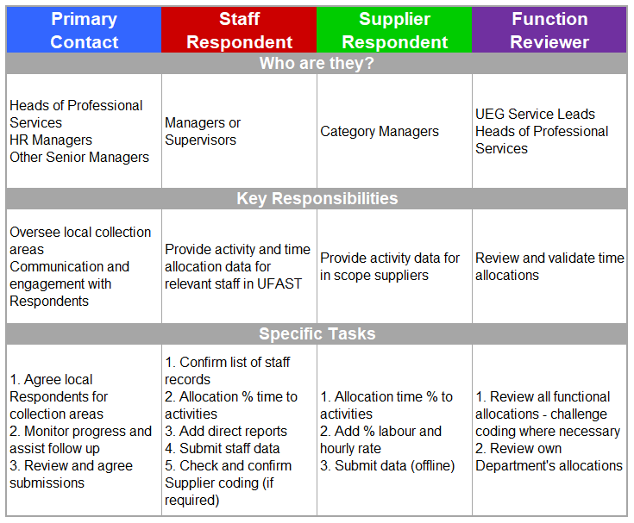

I am a Respondent, where can I access training and guidance support?

A SharePoint site is in development and access will be provided for all Respondents, Primary Contacts and Functional Reviewers in the coming weeks.

Are there any other tools/strategies for the validation of data to ensure that information is correct?

We employ a number of strategies to ensure the data collected, in addition to being complete, is as accurate and representative as possible. We will provide all Primary Contacts with progress reports at regular intervals during the collection, so that they can review the data that is being submitted and follow up anything that may need double-checking.

We are also actively encouraging those professional staff members responsible for completing the data collection (Respondents) to consult with colleagues directly if they are unsure about what activity allocations should be submitted.

What is the Service Effectiveness Survey?

The Service Effectiveness Survey is undertaken to seek feedback from colleagues regarding some of the key support services at the University: finance, purchasing, human resources, information technology, marketing and student recruitment, research support, student and teaching support and facilities management.

The survey is not designed to give specific feedback on individuals, but focuses on the overall service delivered. Even so, all responses to the survey are confidential and no-one at Leeds will have access to individuals’ feedback.

The Service Effectiveness Survey will be undertaken later in the year and colleagues will be contacted in advance of the start date.

What happened with the data that was collected in 2015 and 2017?

UniForum provides one of a number of data sets that has helped inform an evidence-based approach to the planning of professional services that support academic activities at Leeds. Data from the 2015 and 2017 collections has been used in a variety of ways, including the development of business cases for investments to improve services, such as the Corporate Processes and Systems Programme and the Student Lifecycle Programme.

Individual heads of professional services have also used the data in different ways, including providing evidence of where headroom could be created within a service, by operating more efficiently, and thereby allowing the service to respond to new demands within its existing budget and more generally reflecting on what the data tells them in preparation of their Integrated Planning Exercise (IPE) submissions.

Although we expect UniForum to help us improve the efficiency and effectiveness of our professional services, the process is not being driven primarily by the need to make savings.

How has the survey led to administrative efficiencies within other universities that have undertaken it?

In Australia and New Zealand, where the programme has been running for longer than in the UK, universities also chose to join UniForum for a variety of reasons and use the resulting information in different ways, depending on their individual circumstances and objectives.

Some recent outcomes at other universities have included:

- programmes for the continuous improvement of service delivery
- business case support for investment in systems; and
- skills upgrades for service delivery teams.

Should you have any other queries in relation to UniForum, please do not hesitate to contact the UniForum Programme Team.

